1. | Perform Kruskal’s algorithm to find the minimum spanning tree of the following graph:  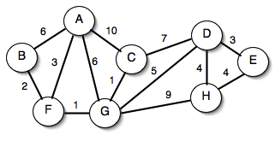 | 10

1. | Perform Kruskal’s algorithm to find the minimum spanning tree of the following graph:  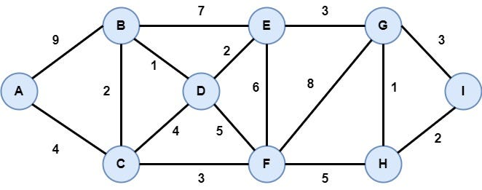 | 10

1. | Perform Kruskal’s algorithm to find the minimum spanning tree of the following graph:  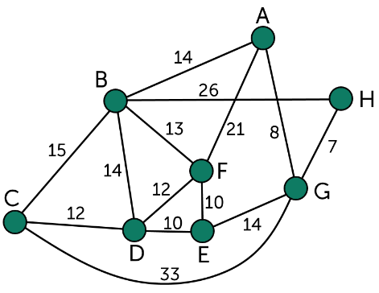 | 10

